Town Team Board Update – July 2025
This update report has been produced in lieu of the Board meeting planned for July 22nd, but which has been cancelled due to known holiday absences.
Sevenoaks BID
The initial work of the Steering Group is nearly complete. A copy of the latest Business Plan iteration is attached. It has been sent to our consultants, British BIDs for checking before being printed. The process towards ballot is about to commence. The process takes about three months, and it is hoped to be able to run the ballot in October or November 2026.
We need all Town Team Board members and Councillors to be fully aware of the Plan and to canvass businesses to help them understand what the BID is all about and how it can help them.
When we reach the ballot stage all qualifying business will be sent a printed copy of the Business Plan together with the ballot papers. Meanwhile a one page Q&A sheet is attached, and further info can be seen at www.sevenoaksbid.co.uk.
Meanwhile we especially need these conversations to take place amongst qualifying businesses, that is:
- Those with a rateable value exceeding £15,000 - let me know if you need me to check any.
- Not charities, schools or NHS Hospitals
- Aim especially for offices, industrial etc

Then feed back to me your outcomes please.

Health & Wellness Fair


This new event took place on 30th May when 43 exhibitors took part. The open-air gazebo area was completely full while in practice another the marquee could have accommodated another 3 or 4 stands – a lesson learned for 2027 when the Fair will be held on 22nd May. A demonstration area was incorporated and well used by a variety of exhibitors including a dance school, Rock Choir, exercise business, cheer leaders and others. Cllr O’Hara also ran a tai chi class.
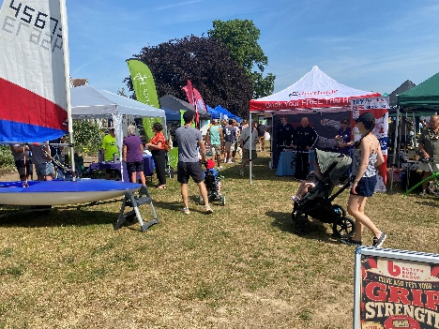
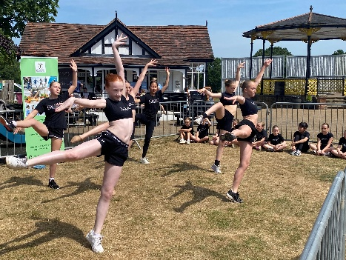
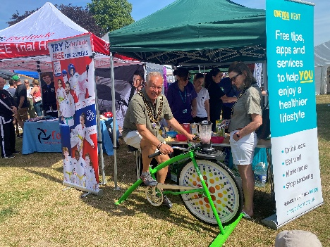
Sevenoaks Business Show
This was held on 5th June. All the stalls were sold out. The speaker was Caroline Beeson of the Mayor’s charity, Hospice in the Weald.
After the show Survey Monkey was used to assess the views and reactions to the Show. The outcome, which is largely supportive, is appended.

Public Realm
Presently the main project is an attempt to improve the appearance and attractiveness of The Shambles. As part of LGR, the District Council has agreed to transfer the freehold to the Town Council, so STC is not currently in a position of authority, but the businesses surrounding The Shambles are largely suportive of the idea.
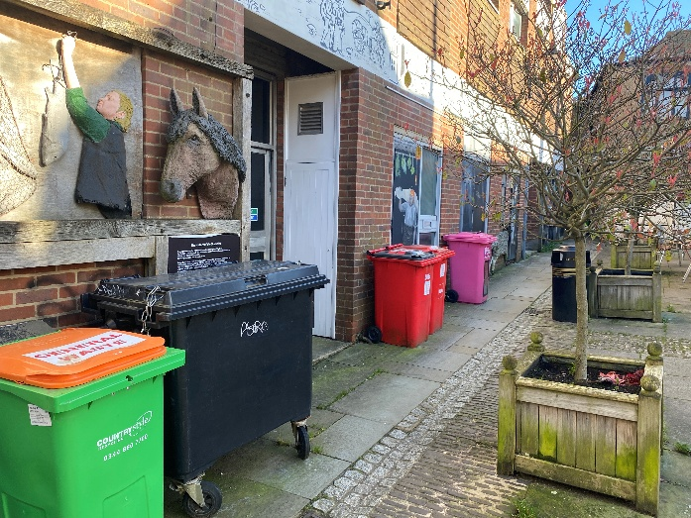

A survey of bin useage has been undertaken and the summary circulated to the businesses. It shows a multiplicity of bins, bin types, collection dates and contractors. The next step is to see wheteher we can work with a single waste contractor to improve the situation, and maybe reduce the costs to the businesses.
One immediate outcome has been at The Fish Shop where a leaking bin has been replaced, collections doubled, and bleach cleaning increased from once to twice a day. The move has been good for his business. Here is part of a follow up email from the shop:

“ Yeah I feel the improvements we have made have dramatically changed the smell, with the new bin and the extra collection I think it is really been positive and going forward I think we have potentially resolved the situation to the best of what it can be. It’s also been great to see the support from our customers I know the people that commented were not customers of ours and they had obviously made complaint. It’s nice to feel supported as a local business by your customers sadly a lot of people do not understand the challenges that comes with owning food business.” – Greg Chester.
Sevenoaks Street Food Festival
This was hugely successful in 2025 and returns on Saturday 29th August. It is run by Caroline Druce-Smith of Heart of Sevenoaks.

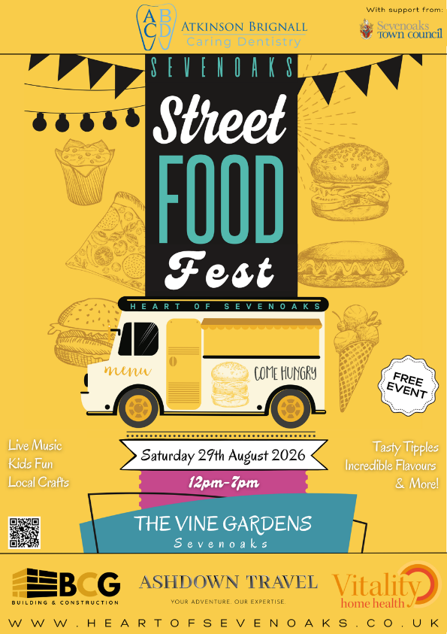

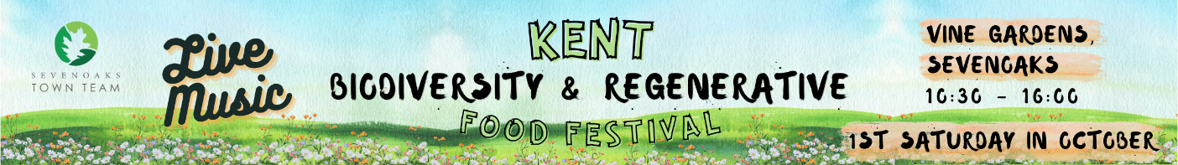
The Kent Biodiversity & Regenerative Food Festival

This is an evolution of the Vegan Market and is being run by the same people, so the overall format will be similar with a number of food stalls being present, but to include a whole range of ancillary specialisations such as The Kent Guild of Spinners, Dyers and Weavers. See more at https://www.regenerativefoods.co.uk/events-media/kent. It takes place on Saturday 3rd October.
Note that as this is the first such market in the county that it has been styled using Kent as the descriptor, so expecting to draw in a wider geography of both exhibitors and visitors.

Holly Party 2026
We have started marketing early this year – in a heatwave!

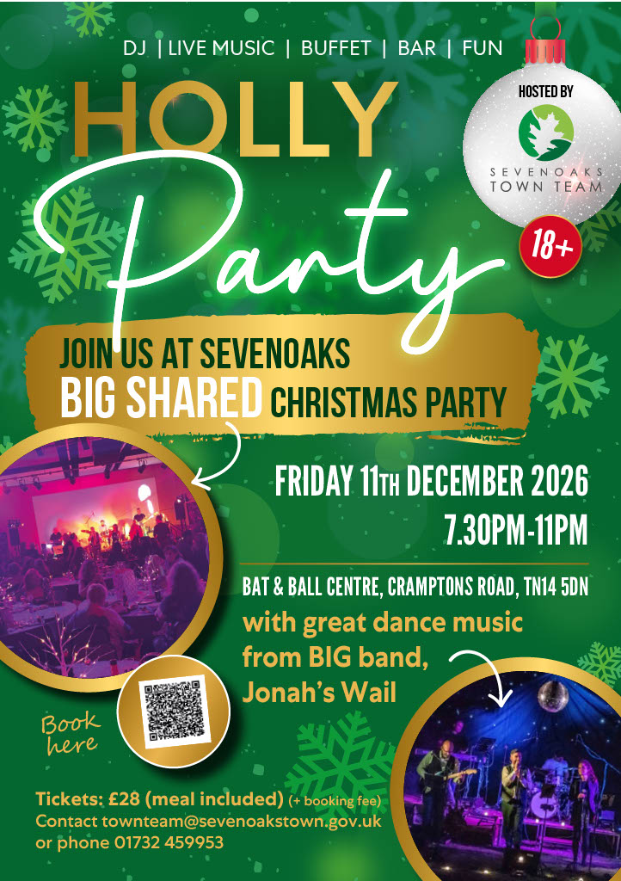
Please book here!



The White Company
The former Starbucks unit in the High Street will soon be occupied by The White Company | Luxury Clothing, Homeware and Gifts.

Next Meeting
This will take place on Wednesday 30th September.

