Sevenoaks Town Team
Executive Board Meeting

6:30pm: Wednesday 30th September 2026

To be held at
The Council Chamber, Sevenoaks Town Council, Bradbourne Vale Road TN13 3QG

Executive Board

Representing | Number | Current Member | Current Organisation
Sevenoaks Town Council | 5 | Cllr Nigel Wightman  Cllr Victoria Granville  Cllr Libby Ancrum  Linda Larter MBE  Mike Reid | CEO / Town Clerk  Town Team Facilitator
Sevenoaks District Council | 1 | Cllr Graham Clack
Kent County Council | 1 | Cllr Streatfeild MBE
Transport | 3 | Cllr Tony Clayton (Chair)  Austin Blackburn  Jack Heidry | Sevenoaks Rail Travellers Association  Go Coach  Southeastern
Leisure Facilities | 3 | Shane Smith  Andrew Eyre  Rebecca Ibbotson | Leisure Centre  Stag  Knole
Chamber of Commerce | 1 | Dawn Blee CEO
Blighs Meadow | 1 | Rob Dummett | Estama
Sevenoaks Society | 1 | Richard Baxter
Large Business | 2 | Maxine Morgans (Vice-Chair)  Elizabeth Dolding | Specsavers  Warners Solicitors
Small Independent Business | 1 | Roberta Ware  Vacant | Francis Jones Jewellers
Residents Associations | 4 | Elizabeth Purves  Byron Brown  Avril Hunter  Andrew Pring | Hollybush RA  Bradbourne RA  Redlands RA  Knole Paddock RA
Police | 1 | Nick Hubbard/Tom Costin | Kent Police
Sevenoaks District Seniors Action Forum | 1 | Cllr Merilyn Canet | Sevenoaks District Seniors Action Forum
Business Crime Reduction Partnership | 1 | Dennis Glasspool | Business Crime Reduction Partnership
 | 26

AGENDA

- Apologies for Absence

- Declarations of Interest

- Minutes

Given that the July meeting was in a summer recess and members provided with update information, to receive and approve the minutes of the Board Meeting held on 13th May 2026

- Business Improvement District (BID).

At Sevenoaks Town Council EGM held on 24th August 20024 the following resolution was passed: Sevenoaks Town Council on behalf of Sevenoaks Town Team RESOLVED to proceed with the actions required to progress the Sevenoaks BID referendum subject to final agreement on timetable.

Subsequent to this a formal “Proposal” setting out all details of the BID and its formative history, together with all the arrangements that need to be agreed with the District Council regarding the ballot and levy collection arrangements has been drafted for discussion and agreement with SDC.

A promotional video has bas been filmed and if completed in time for the meeting will be shown then.

- Wayfinding

Stalled for lack of funding, development of the scheme is now proceeding with thanks to KCC having awarded a “Local Bus Intervention Grant” of £260,000 with STC providing match funding of £51,225.

- Public Realm

Discussions initiated with Sevenoaks School about the Battle of Solefields plaque set in the wall by at the junction of Tonbridge Road and Solefields Road were originally about restoring the plaque which had become virtually illegible. The School is to be thanked for taking the idea a step further by commissioning and installing an entirely new plaque as pictured.
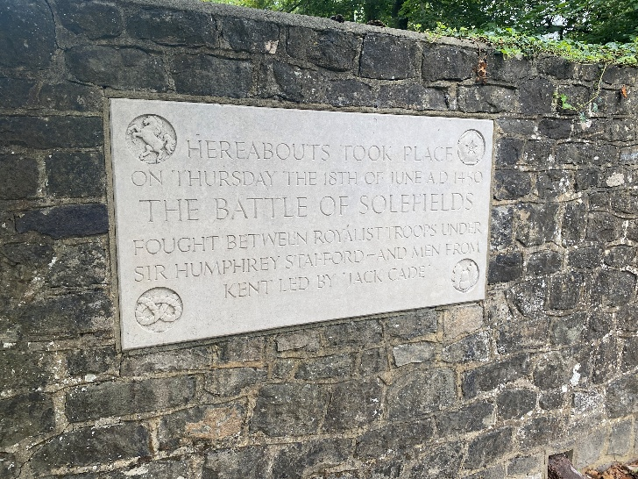

- The Shambles

An introduction to ideas designed to improve the area.

- Health & Wellness Initiative

The Fair was a great success with 47 exhibitors attending and a good public presence. Town Team member, Andrew Pring is thanked for having joined STC staff in managing the event.

All feedback was positive and the event will be run again on Saturday 22nd May 2027.

- Sevenoaks Street Food Festival

This took on Saturday 29th August in appalling weather. Visitor numbers were naturally greatly reduced, but so far as is known at the moment, the event will run again in 2027.

- KENT Biodiversity & Regenerative Foods Festival

This is a development of the Vegan Market and takes place on Saturday 3rd October. 35 stalls made up of 13 community/charity/grower stalls and 22 businesses/caterers have booked, some 10 more than the usual Vegan market numbers. Being new, and the only such event in the County, the opportunity has been given to use the name “Kent” rather than “Sevenoaks” in the title.

This will take place on Saturday 3rd October
- Sevenoaks Business Awards 2026

Booked for Friday 20th November – an update

- Holly Party 2026

To be held on Friday 11th December – an update

- Members Organisations

To receive updates from partnership members and their organisations’ activities.

- Date of next meeting – November 25th.

