Sevenoaks Town Team
Executive Board Meeting

6:30pm: Wednesday 21st January 2026

To be held at
The Council Chamber, Sevenoaks Town Council, Bradbourne Vale Road TN13 3QG

Executive Board

Representing | Number | Current Member | Current Organisation
Sevenoaks Town Council | 4 | Cllr Nigel Wightman  Cllr Victoria Granville  Cllr Libby Ancrum  Linda Larter MBE  Mike Reid | CEO / Town Clerk  Town Team Facilitator
Sevenoaks District Council | 1 | Cllr Graham Clack
Kent County Council | 1 | Cllr Streatfeild MBE
Transport | 3 | Cllr Tony Clayton (Chair)  Austin Blackburn  Jack Heidry | Sevenoaks Rail Travellers Association  Go Coach  Southeastern
Leisure Facilities | 3 | Shane Smith  Andrew Eyre  Rebecca Ibbotson | Leisure Centre  Stag  Knole
Chamber of Commerce | 1 | Dawn Blee CEO
Blighs Meadow | 1 | Stephen Butler | Workman plc
Sevenoaks Chronicle | 1 | None available
Sevenoaks Society | 1 | Richard Baxter
Large Business | 2 | Maxine Morgans (Vice-Chair)  Elizabeth Dolding | Specsavers  Warners Solicitors
Small Independent Business | 2 | Roberta Ware  Vacant | Francis Jones Jewellers
Residents Associations | 4 | Elizabeth Purves  Vacant  Byron Brown  Avril Hunter | Hollybush RA  Eardley Road RA  Bradbourne RA  Redlands RA
Police | 1 | Nick Hubbard/Tom Costin | Kent Police
Sevenoaks District Seniors Action Forum | 1 | Cllr Merilyn Canet
 | 27

AGENDA

- Apologies for Absence

- Declarations of Interest

- Minutes

To receive and approve the minutes of the AGM & Board Meeting held on 12th November 2025

- Constitution of the Town Team Executive Board.

Any further nominees?

- Blighs Meadow

The freehold investment has just been sold, and the managing agents have been replaced by London based, Estama. A meeting is being arranged to introduce relevant STC staff and to learn of the new owners plans for improvements to the centre.

- Business Improvement District (BID).

At the time of the last Executive Board meeting the design of the Business Plan brochure was about to be refocussed to reflect the theme “What’s in it for me”. Almost as that was done the Autumn Budget was announced. One of the Budget’s main provisions was in relation to Business Rates.

The Valuation Office Agency has released the new rateable values applicable from April 2026 and almost without exception, in Sevenoaks, the majority of properties saw an increase. This is not based on a whim, but a reflection of the rents being paid as at the date of valuation being April 2024.

The Chancellor announced new multipliers with a reduced rate for businesses in the Retail, Hospitality and Leisure. However, on testing a range of local hereditaments (properties) the combined effect still produced increased payments. Presently there is a review of the reliefs to be made available, particularly with respect to pubs, and it is going to be some time before businesses will have a clear understanding of their new liability and how it has been assessed.

BIDS are funded by a levy based on Rateable Value.

Given the circumstances the Board needs to discuss and consider how to progress.

- Town Centre Masterplan Public Consultation Update

Background
Public consultation on Sevenoaks Town Council’s draft Town Centre Masterplan took place between 28th June and 30th September 2025. This included a significant extension, due to it

coinciding with another significant Town Council consultation regarding Local Government Reorganisation and District Council-owned assets.

Copy of the consultation materials remain publicly available via the following links:
Draft Town Centre Masterplan
Information Boards
Update on progress
Sevenoaks Town Council’s consultants, Urban Initiatives, have since prepared two draft consultation reports – one for the Town Centre Masterplan consultation as well as one for the St John’s Hill Area Masterplan which took place earlier in the year between 10th March and 21st April 2025.

These draft reports, summarise the feedback received during the consultations, and make recommendations as to potential amendments, are currently pending review and approval of Town Councillors before their publication.
Next steps
Once finalised, the consultation report and subsequently amended Masterplans will be published, and their contents considered by the Town Council via its Committee structure, for final adoption. There is not currently an anticipated timeline for this.
Collaboration and cohesion with Sevenoaks District Council projects
Recognition of the draft Masterplans was included in the Sevenoaks District Council’s draft Local Plan, which underwent its Regulation 18 Public Consultation between October and December 2025. This is via Policy SEV1, which noted “The Town Council is also in the process of developing further Town Centre and St John’s Hill Area Masterplans which will help guide future development proposals and drive improvements to the experience and offering of these centres”.

This is a very positive development, strengthening the potential material weight of the Masterplans and their aspired influence in both the design of future planning applications as well as potential infrastructure improvements.

The draft Town Centre Masterplan has also been included in the District Council’s detailed Invitation to Tender for the second stage of the Land East of High Street procurement stage. STC Officers and Councillors (Cllr Victoria Granville) met with SDC Councillors Cllr Roddy Hogarth and Cllr Nigel Williams in November 2025 to discuss the contents of the draft Masterplans and ensure that they align with the District Council’s evolving vision for the Land East of High Street revitalisation project.

This is a further highly welcomed and positive development, particularly as the Masterplan reinforces the importance of establishing a Cultural Quarter, enhanced links and connections between cultural offerings, and identifies a further potential public open space. It also makes recommendation on building heights, as well as potential bus movement options.

- Sevenoaks Business Awards 2025

These took place on 14th November. The Awards Gala Dinner was held at the Bat & Ball Centre where Jenny Ryan (The Vixen) was the speaker and magician Bob Pound was up to his tricks. Jamie Wilson, the producer of the Sevenoaks panto for the last 15 years gave an insight into its development and importance to the town.

The public again engaged heavily with the process, firstly in nominating businesses and then secondly in voting for their favourites. Each person can only vote once, and 2760 votes were cast this year.

The winners were:
Independent Business of the Year
Happy Tails Doggy Daycare

Larger Business of the Year
Rockdale Village

Sustainability in Business
Franks Barbers

Health & Wellness
Bluebird Care

New Business of the Year
1 = Eleanor Clark Dance Company
1 = Miles Martial Arts

Judges Choice of the Year
Jamie Wilson

Customer Choice Business of the Year
Happy Tails Doggy Daycare

It should be noted that The TN Card is proposing to hold the “Sevenoaks District Business Awards” in 2027. The attached article advises.

- Christmas Best Dressed Window competition

The Christmas competition was supported by the Chamber which provided bottles of bubbly for the winners.

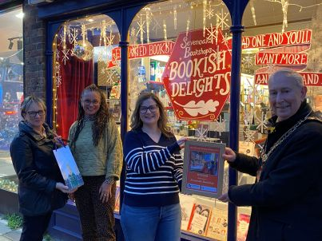
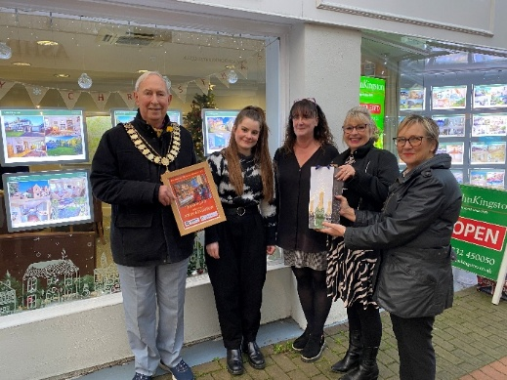

Retail winner - Sevenoaks Bookshop
Office winner – John Kingston

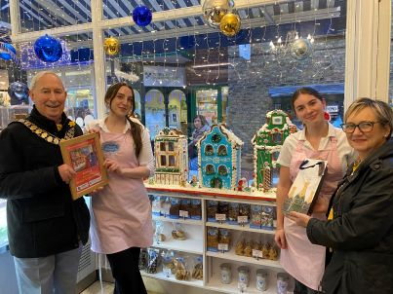

Hospitality winner - Dulce’s Patisserie

- Holly Party 2025

This year’s party was enjoyed by all and deemed to have been the best we have run. Jonah’s wail is an 8 piece band which provided brilliant music throughout.

Ticket sales for this event remain stubbornly low and though the best to date, there were only 67 paying attendees and a total of 90 people there including the band, technical and STC staff.

- Health & Wellness Initiative

This is a joint project between The Better Body Group and the Town Team. The concept is based on elevating the general health of Sevenoaks residents through removing barriers and opening opportunities.

Having started work on the Initiative, interest has grown quickly and several people and businesses want to become involved. The most tangible outcome for 2026 will be a Health & Wellness Fair to be held on The Vine on 30th May. It is intended that around 30-35 stalls will be present, made up of roughly a third being sports or activity related, one third for healthcare providers of varying types and one third of healthy food/cookery.

Restaurants and cafes are about to be canvassed to promote healthy eating through window stickers showing those places which provide any or all of the following:

- Low calorie
- Low salt
- Low carbohydrate
- Balanced meals
- High Protein
- UPF - free (UPF = ultra processed food)

Work is also progressing on creating a new Health & Wellness section on the STC website. The first component will be a directory of local Sports & Activities Clubs, and a major part of that will be showing information which reduces the barriers to joining. Further pages are planned for local health providers, healthy eating etc.

- Vegan Markets

The Spring market will take place on 4th April. The Autumn Market (run by the same people) will become a “Biodiversity & Regenerative Food Festival” on Saturday 3rd October.

- Sevenoaks Street Food Festival

This will take place in September 2026 with the date to be confirmed

- Sevenoaks Bike Festival

Sevenoaks Bikes cannot yet confirm they will run this in 2026.

- Members Organisations

To receive updates from partnership members and their organisations activities.

- Dates of future meetings

25th March
13th May

